Population Structure and Connectivity of the Atlantic Ribbed Mussel and Community Involvement with Surveys of the Ribbed Mussel and Salt-Marsh Die-off

Maggie Schedl

**Overview**

Salt marshes in the Western Atlantic, and specifically New England are experiencing a decline; termed salt marsh die-off. Marshes and estuaries represent one of the most productive ecosystems on the planet, serve as nurseries for many marine species, and protect the coast from storms. Salt marshes are an important area of concern for conservation purposes, yet they are complex systems, and we only know only a little about the organisms that reside in and form them. Atlantic ribbed mussels are an essential component of healthy salt marshes, living in a mutualistic relationship with cordgrass and facilitate sediment and marsh stability against erosion. However, almost nothing is known about the population and genetic structure of ribbed mussels, and they are a wide-ranging species across the Eastern coast of the United States. Ribbed mussels have an impressive set of adaptations for the intertidal marsh life that increase the likelihood of distinct, locally adapted populations. With their habitat declining, our knowledge gap of the diversity of their species limits our management of populations. Additionally, the role of the ribbed mussel in salt marsh die-off, specifically in herbivory of cordgrass by burrowing crabs, has not been investigated. The objectives of this proposal are to use genomic techniques to study the population structure and connectivity of the Atlantic ribbed mussel and engage local Rhode Island minority communities in re-surveying marshes of RI with respect to marsh die-off and ribbed mussel populations.

**Intellectual Merit**

Wide-spread Atlantic ribbed mussels create an opportunity for investigating population structure and connectivity in a group relatively devoid of human-mediated movement as it is not a fishery species. Current NGS technologies and programs for processing NGS data continues to evolve for use in non-model organisms, and the pioneering of a genomic study on the ribbed mussel would open the species up for research on a boarder number of topics, including on its unique physiology and on the mutualistic relationship with smooth cordgrass. The necessity to survey and determine the relationships that play roles in salt marsh die-off in New England are imperative, as habitats continue to decline, and the impact of Climate Change is likely to exacerbate declines.

**Broader Impacts**

All data for both aims of this proposed project will be made publicly available. This is specifically important because of the goals for community involvement, engagement, and broad scale teaching. Well-documented steps of analysis and a tutorial made for using the genomic data as a teaching tool and to promote reproducibility in science will be curated on GitHub. Surveys of local Rhode Island marshes outlined in Aim 2 will be organized, conducted, and the data analyzed by students from a local underserved minority community. If the results from the surveys are presented at conferences, those students will be the primary presenters. Additional emphasis will be put on involving parents and older community members as well to foster a group effort and community ties to a local ecosystem and stewardship in future conservation efforts.

**1. Background:**

Salt marshes are one of the most productive and most threatened ecosystems on our planet (Barbier 2011). It is becoming increasingly apparent that salt marshes and estuaries are essential ecosystems for the productivity and function of our oceans. Intertidal areas are sites of high primary production and serve as nurseries for a wide variety of species. Additionally, marshes can tolerate a wide range of tidal volumes, and this protects the coast and human coastal communities from devastating storms and waves (Barbier et al. 2011; Duarte et al. 2013).

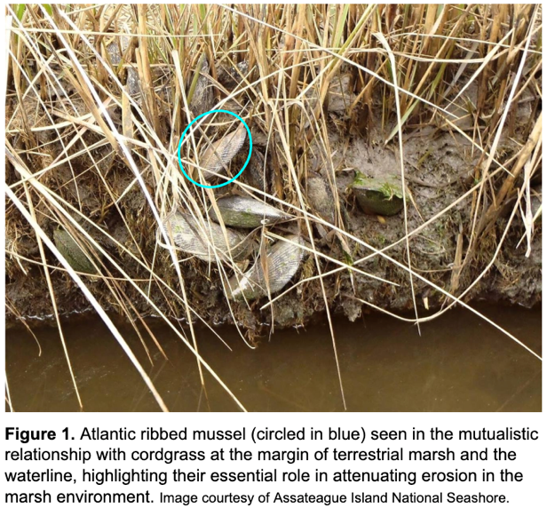A common resident of salt marshes is *Geukensia demissa,* hereafter referred to by its common name the Atlantic ribbed mussel*.* Ribbed mussels are often found living in a mutualistic relationship with another ubiquitous marsh resident ﻿*Spartina alterniflor*, or smooth cordgrass, as well as other *Spartina* species, hereafter called cordgrasses. Ribbed mussels are found living near or on the root systems of cordgrass. It is common knowledge that plant root systems are imperative in ground stability in preventing erosion and disruption (ex. Abernethy & Rutherfurd 2000). However, few animals have been shown to play a role in erosion prevention as well. Ribbed mussels attach their byssal threads to the roots of cordgrass, trapping sediment in and facilitation stability of the marsh (﻿Moody 2012). They are also known to form large aggregations or beds and settle or attach on one another, which while a competitive environment for the mussel, aids in stability of the soft sediment of the marsh (Bertness & Grosholz 2009). Additionally, they provide ammonia in the form of waste which acts as a natural fertilizer for the cordgrass (﻿Jordan and Valiela 1982), which in turn increases the growth of cordgrass and the stability of the marsh sediment. Primary production of marsh systems increases with mussel density, as well as there are positive effects of cordgrass on the growth and reproduction of ribbed mussels (Bertness 1984). This may be because the relationship between ribbed mussels and cordgrass is truly mutual, the mussels are one of the only known species of mollusk that readily feeds on decomposing cellulose from cordgrass (Kreeger & Newell 2001).

Ribbed mussels have an immensely wide temperature and salinity tolerance range, up to 56 degrees Celsius and 70ppt salinity (Lent 1969). While most often found at the marsh edge, ribbed mussels can be found higher up in the intertidal zone as well (Coen & Grizzle 2007). They exhibits the rare behavior of “air-gaping” by opening its two shells when the tide is out, which is thought to help thermoregulate the animal, and as a mechanism of respiration and oxygen consumption (Kuenzler 1961). Most of the literature on the Atlantic ribbed mussel is from before the genomics revolution for non-model organisms. With such interesting behavior, mutualism in cornerstone environment, and physiological capabilities, the ribbed mussel has been neglected in the age of NGS research.

**2. Specific Aims:**

The objectives of this proposal are to apply population genomics techniques to determine the population diversity, structure, and connectivity of the Atlantic ribbed musselacross the majority of its native range: from the coast of Maine to Florida. A broader outcome of such a large-scale population genomic survey is to open up the ribbed mussel to an array of genomic techniques and questions that it is uniquely ripe for study. Additionally, salt marsh die-off in many New England marshes occurs within the cordgrass, the marsh grass most closely associated with the ribbed mussel*.* We aim to determine the relationship between presence and density or the ribbed musseland degree of salt marsh die-off.

**Aim 1**. To determine the population structure and diversity of *Geukensia demissa* on the Atlantic coast and infer any population connectivity that may exist.

**Aim 2.** To involve local minority communities in determining if *Geukensia demissa* plays a role in attenuating salt marsh die-off by conducting surveys in New England of salt marshes and correlating level of die-off and abundance of *G. demissa*.

**3. Population Structure of *Geukensia demissa* (Aim 1)**

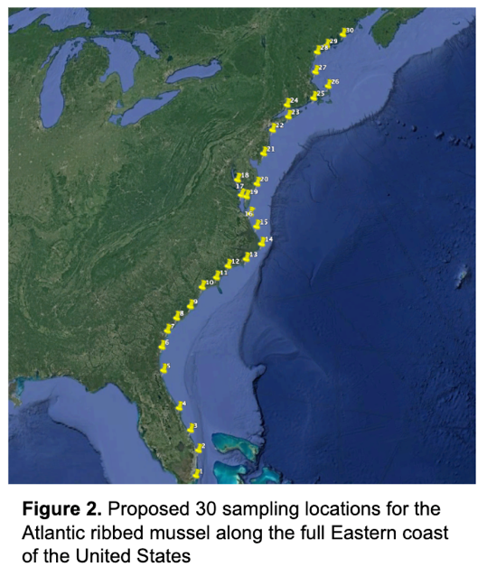We will investigate the population structure in the ribbed mussel across most of its geographical range using genomic data. The Atlantic ribbed mussel represents a sessile intertidal bivalve that has not been farmed or a part of a fishery (Massie & Young 1998), and thus an opportunity to investigate population structure and connectivity of such a group without the previous history of human-motivated movement. Large genomic datasets are the cutting edge of the field of population genomics, ecology, and evolutionary biology. Thirty sampling sites spanning the geographic range of *G. demissa* are proposed (Fig. 2). At each location, a random sample of 10 individuals will be taken whole and then flash frozen to preserve their DNA. Tissue biopsies from mantle will be used for DNA extraction, and DNA will be processed for sequencing with a double digest Restriction Sites Associated DNA (ddRAD) sequencing protocol (Peterson et. al 2012). ddRAD is a relatively inexpensive method for Next Generation Sequencing (NGS), which is ideal for this study with a proposed number of 300 individuals to be sequenced. The large number of individuals is necessary to elucidate fine scale population structure that may be present and to be statistically replicable. A dual set of restriction enzymes reduces the size of the genome in a largely un-biased fashion, which leads to the same loci being sequenced after a size selection step. This method allows for detection of genomic variants, most commonly single nucleotide polymorphisms (SNPs), from the same loci across all individuals. Such a dataset has incredible genomic power, and SNPs from RAD datasets, or the very similar Genotype By Sequencing, has been used widely in population genomic literature across all taxa (see Silliman (2019), Puritz et al. (2016), Manthey et al. (2019), and many more). While no genomic resources currently exist for the ribbed mussel, the genome of the Mediterranean Mussel *Mytilus galloprovincialis* (Murgarella et al. 2016), as well as pipelines with efficient *de novo* assembly (see Puritz et al. 2014) will be used.

Population structure, diversity, and connectivity will be determined with the SNP dataset generated from ddRAD sequencing. Clustering analysis such as Principle Components Analyses (PCAs) will be used to see if populations group genetically based on no prior assumptions. Population connectivity and historical migration will be investigated with programs such as ADMIXTURE and TreeMix. This information will provide insight in the long-term viability of the species as their habitat declines, and if there are any distinct populations. We will also assess whether the morphological distinctness of the one proposed subspecies *G. d. granosissima* (Sowerby, 1914) (Sarver et al. 1992) from Florida is distinct genetically (Sarver et al. 1992). Genetic studies have both confirmed and refuted previous subspecies and species designations for many species (Supple & Shapiro 2018).

**4. Role of *Geukensia demissa* in die-back of New England salt marshes (Aim 2)**

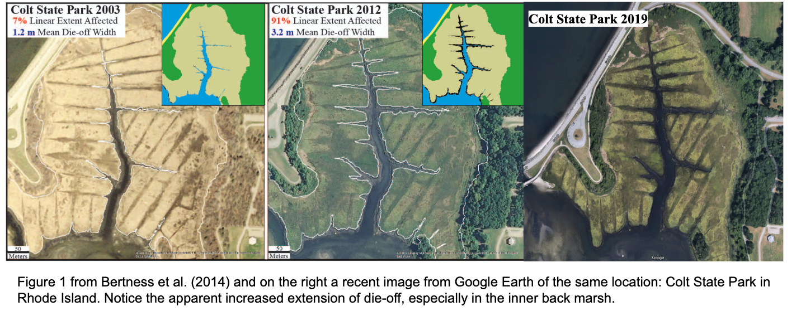Salt marshes represent a productive, ecologically and economically important ecosystem, and while there are not reliable estimates on the monetary value of the ecosystem service of erosion control, it is often cited as one of the most important resources marshes provide (Barbier et al. 2011). Unfortunately, salt marshes in the Western Atlantic, and particularly close to home, in New England are experiencing salt marsh die-off (Bertness & Silliman 2008). Within the last ten years, salt marsh die-off has been newly reported in Narragansett Bay (Bertness et al. 2014). Multiple studies found strong suggestions that the release of crabs from predator control, mediated by humans, correlated with increased herbivory of cordgrass and burrowing, and causing declines in marsh habitats (Bertness et al. 2014; Bertness & Coverdale 2013; Coverdale et al. 2012). The loss of cordgrass biomass in turn increases erosion and sediment loss. Burrowing crabs and ribbed mussels have been categorized as facilitators of the salt marsh environment, and they both have significant interactions and effects on cordgrass. Hughes et al (2013) highlight that when taking into account the complexity of marsh environments, multiple organisms need to be considered. However, there is a significant knowledge gap in the understanding of herbivory as a key cause for the decline of New England salt marshes. Bertness et al. (2014) made no mention of the ribbed mussel in their discussion of salt marsh decline, yet it is no unrealistic leap to wonder if the presence of aggregating ribbed mussels might protect cordgrass from herbivory pressure and undermining of the sediment.

Re-surveys of the fourteen sites in Narragansett Bay used in the Bertness et al. (2014) study will be undertaken with the two-fold explicit purposes of determining the role of the ribbed mussel in the extent of salt marsh die off, and involving a local Rhode Island high school with a high underserved minority population (yet to be determined) with every step of the process. Students, as well as community and family members, will have a significant role in the planning, implementation, data collection, data analysis, and writing and publication of any findings from the surveys. Involvement of minorities in STEM research, and giving them the credit deserved for effort put in, should not be an after-thought, and studies that involve high school students and underserved minorities do produce academically rigorous work worthy of publication. Preliminary satellite imagery of marshes in Narragansett Bay show an increase in salt marsh die-off since the study by Bertness et al. (2014) (Fig. 3), showing the necessity of further research on the causes and mediation of die-off.

**Intellectual Merit**

As to date, research on the Atlantic ribbed mussel has not been thrust into the burgeoning field of genomics. Only one almost thirty year old study has used genetic markers on this species, and the authors only used four samples and the antiquated method of alloenzymes in their analysis (Sarver et al. 1992). Despite this, we suggest that the ribbed mussel is a species ripe for extensive study based on its connection to an essential and declining habitat, its ubiquity along the entire Atlantic coast of the United States, and its impressive physiological capabilities. However, management, research, and decisions aimed at the conservation of vulnerable salt marshes need to be informed by knowledge of population structure, diversity, and connectivity (Miller & Ayre 2008). This study aims to lay the groundwork for many further studies on the ribbed mussel by providing necessary background on the population composition of the Atlantic ribbed mussel. As NGS and other molecular techniques are becoming part of the ecologist’s, conservation biologist’s, and evolutionary biologist’s toolkit, the utility of non-model organisms like the ribbed mussel are becoming apparent in studies based on climate change and adaptation.

**Broader Impacts**

The broader goals of this proposal are multi-faceted. Firstly, all raw genetic data will be made publicly available to facilitate re-analysis and reproducibility of the proposed research. In this vein, a GitHub repository will be curated to include all trimmed and filtered reads, all SNP datasets, and well-documented and annotated files that describe and include all steps taken during the analysis of the genomic data proposed to be generated. A representative section of the data will be subsetted to generate a tutorial of all population structure and connectivity analyses, as methods proposed are typical of population genomics courses, they lend themselves to be a valuable teaching resource. Generation of this data has the secondary goal of becoming a teaching dataset that students, courses, and other institutions can use as real and well-documented data analysis as an alternative to uninformative, unrealistic, and non-relevant simulated datasets. Secondly, the proposed re-survey of salt marshes in Rhode Island has the explicit goal of involving the underserved minority communities of RI in every step of planning, generating, and analyzing rigorous and ecological relevant research. Minorities are not only woefully underrepresented in all STEM fields, but are also often significantly left out in areas such as environmental education, outdoor recreation, and conservation (see LatinoOutdoors.org and Latour, (2014)). Although the surveys would be conducted a few times, an ultimate goal would be to foster a strong sense of community responsibility, concern, and stewardship for local salt marsh habitats that continues after the study has concluded, results been published, and the role of these researchers concluded.

References

Abernethy, B. & Rutherfurd, I.D., 2000. The effect of riparian tree roots on the mass-stability of riverbanks. *Earth Surface Processes and Landforms*, 25(9), pp.921–937. Available at: https://doi.org/10.1002/1096-9837(200008)25:9%3C921::AID-ESP93%3E3.0.CO.

Barbier, E.B., 2011. Progress and Challenges in Valuing Coastal and Marine Ecosystem Services. *Review of Environmental Economics and Policy*, 6(1), pp.1–19. Available at: https://doi.org/10.1093/reep/rer017.

Barbier, E.B. et al., 2011. The value of estuarine and coastal ecosystem services. *Ecological Monographs*, 81(2), pp.169–193.

Bertness, M.D. et al., 2014. Herbivory drives the spread of salt marsh die-off. *PLoS ONE*, 9(3).

Bertness, M.D. & Coverdale, T.C., 2013. An invasive species facilitates the recovery of salt marsh ecosystems on Cape Cod. *Ecology*, 94(9), pp.1937–1943. Available at: https://doi.org/10.1890/12-2150.1.

Bertness, M.D. & Grosholz, E., 2009. Population Dynamics of the Ribbed Mussel , Geukensia demissa : The Costs and Benefits of an Aggregated Distribution. *Ecology*, 67(I 985), pp.192–204.

Bertness, M.D. & Silliman, B.R., 2008. Consumer Control of Salt Marshes Driven by Human Disturbance. *Conservation Biology*, 22(3), pp.618–623. Available at: https://doi.org/10.1111/j.1523-1739.2008.00962.x.

Coen, L.D. & Grizzle, R.E., 2007. The Importance of Habitat Created by Molluscan Shellfish to Managed Species along the Atlantic Coast of the United States. *Atlantic States Marine Fisheries Commission*, Habitat Ma.

Coverdale, T.C., Altieri, A.H. & Bertness, M.D., 2012. Belowground herbivory increases vulnerability of New England salt marshes to die-off. *Ecology*, 93(9), pp.2085–2094. Available at: https://doi.org/10.1890/12-0010.1.

Duarte, C.M. et al., 2013. The role of coastal plant communities for climate change mitigation and adaptation. *Nature Climate Change*, 3, p.961. Available at: https://doi.org/10.1038/nclimate1970.

Kreeger, D.A. & Newell, R.I.E., 2001. Seasonal utilization of different seston carbon sources by the ribbed mussel, Geukensia demissa (Dillwyn) in a mid-Atlantic salt marsh. *Journal of Experimental Marine Biology and Ecology*, 260(1), pp.71–91.

Kuenzler, E.J., 1961. Structure and energy flow of a mussel population in a Georgia salt marsh. *Limnology and Oceanography*, 6(2), pp.191–204. Available at: https://doi.org/10.4319/lo.1961.6.2.0191.

Lent, C.M., 1969. Adaptations of the ribbed mussel, Modiolus demissus (Dillvvyn), to the intertidal habitat. *Integrative and Comparative Biology*, 9(2), pp.283–292.

Manthey, J.D., Boissinot, S. & Moyle, R.G., 2019. Biodiversity genomics of North American Dryobates woodpeckers reveals little gene flow across the D. nuttallii x D. scalaris contact zone. Available at: https://doi.org/10.1093/auk/ukz015.

Massie, F.D. & Young, R., 1998. *The Uncommon Guide to Common Life of Narragansett Bay*, Save The Bay, Incorporated. Available at: https://books.google.com/books?id=K1d3tAEACAAJ.

Miller, K.J. & Ayre, D.J., 2008. Protection of Genetic Diversity and Maintenance of Connectivity among Reef Corals within Marine Protected Areas. *Conservation Biology*, 22(5), pp.1245–1254. Available at: https://doi.org/10.1111/j.1523-1739.2008.00985.x.

Murgarella, M. et al., 2016. A First Insight into the Genome of the Filter-Feeder Mussel Mytilus galloprovincialis. *PLOS ONE*, 11(3), pp.1–22. Available at: https://doi.org/10.1371/journal.pone.0151561.

Puritz, J.B., Gold, J.R. & Portnoy, D.S., 2016. Fine-scale partitioning of genomic variation among recruits in an exploited fishery: Causes and consequences. *Scientific Reports*, 6(April), pp.1–6. Available at: http://dx.doi.org/10.1038/srep36095.

Puritz, J.B., Hollenbeck, C.M. & Gold, J.R., 2014. dDocent: a RADseq, variant-calling pipeline designed for population genomics of non-model organisms. *PeerJ*, 2, pp.e431–e431. Available at: https://www.ncbi.nlm.nih.gov/pubmed/24949246.

Sarver, S.K., Landrum, M.C. & Foltz, D.W., 1992. Genetics and taxonomy of ribbed mussels (Geukensia spp.). *Marine Biology*, 113(3), pp.385–390.

Silliman, K., 2019. Population structure, genetic connectivity, and adaptation in the Olympia oyster ( Ostrea lurida ) along the west coast of North America . *Evolutionary Applications*, (December 2018), pp.1–17.

Supple, M.A. & Shapiro, B., 2018. Conservation of biodiversity in the genomics era. *Genome Biology*, 19(1), p.131. Available at: https://doi.org/10.1186/s13059-018-1520-3.